Root Cause Analysis of the bug found flask sample app
Title: App Randomly Crashes on Requests
Date: 5-Nov-2025
Prepared by: Vivek Prasath.S
1. Problem Description:
The Flask app intermittently fails with a random exception, causing HTTP 500 errors.
2. Impact:
Users intermittently experience downtime; affects reliability and testing.
3. Evidence:
- Logs show: Exception: Random failure occurred!
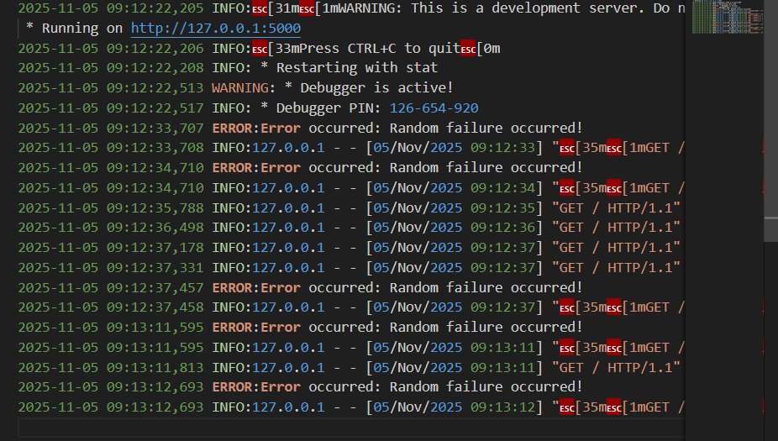
evidence
4. Root Cause:
The index() function intentionally triggers random exceptions without proper error handling.
5. Corrective Action:
Implement try/except block and add structured logging to capture detailed error info.
6. Preventive Action:
Add unit tests and health checks to detect similar errors early.
Fix:
if __name__ == '__main__':
app.run(debug=True)

